**Exercise 1: Setting Up JUnit**

**Scenario :** Set up JUnit in a Java project to start writing unit tests.

**Steps:**

1. Created a new Maven-based Java project with the name “Demo” in VsCode(IDE)

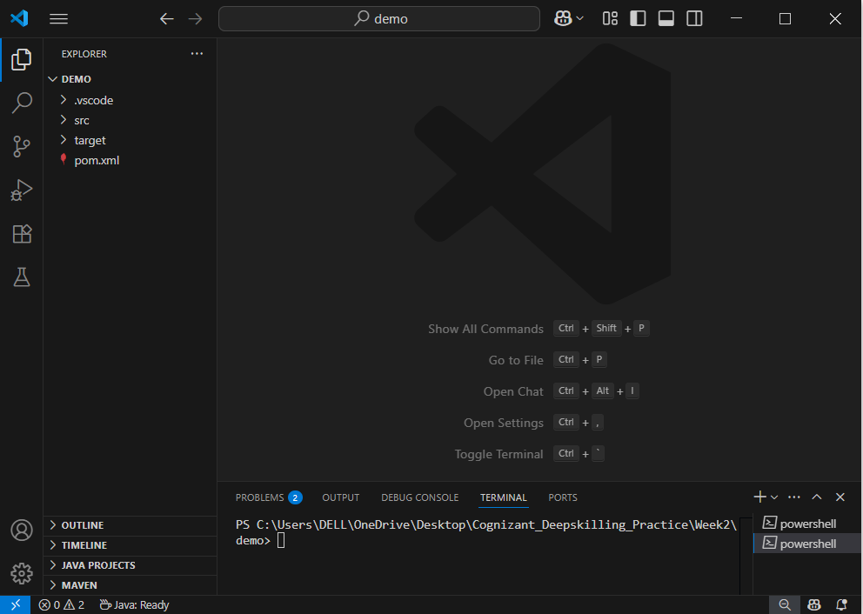

1. Added JUnit dependency to pom.xml

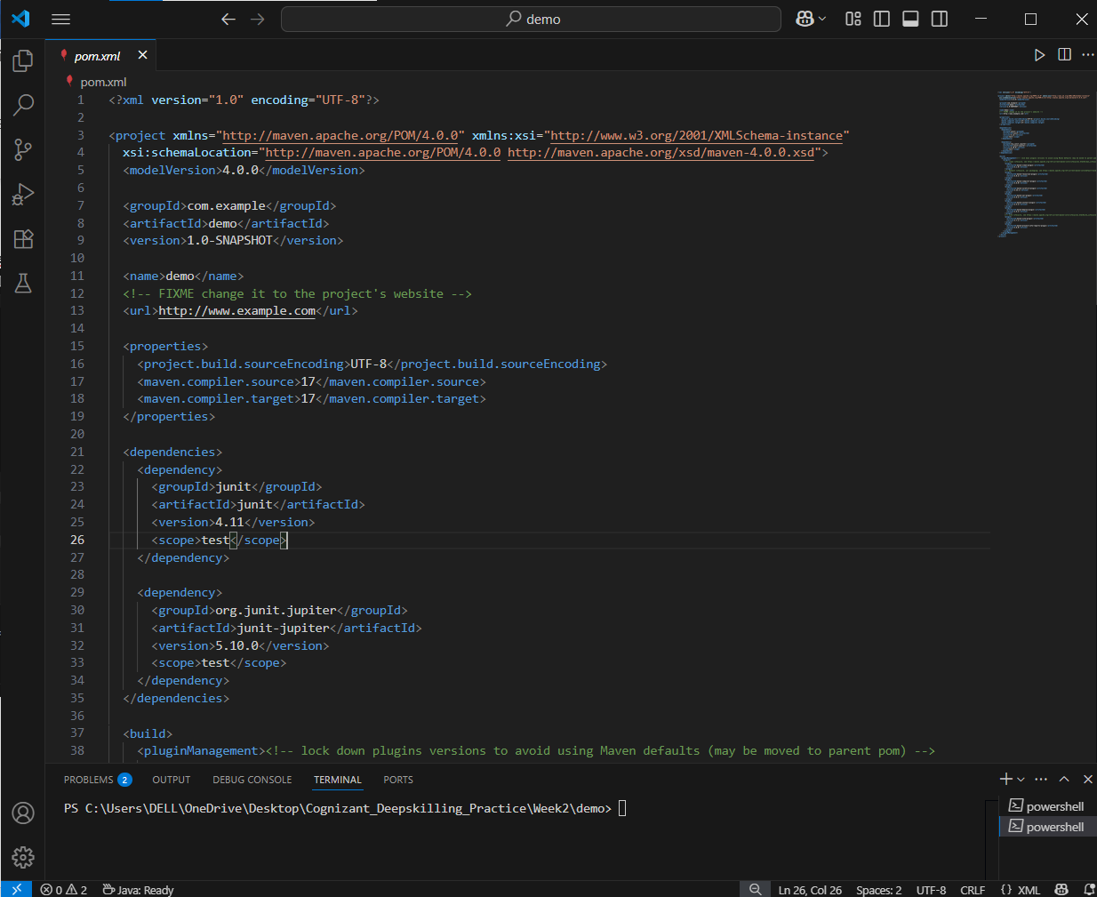

1. Created a new Test class named CalculatorTest in my project

